***EXPERIMENTAL ANALYSIS***

***RESIDUAL ENERGY:***

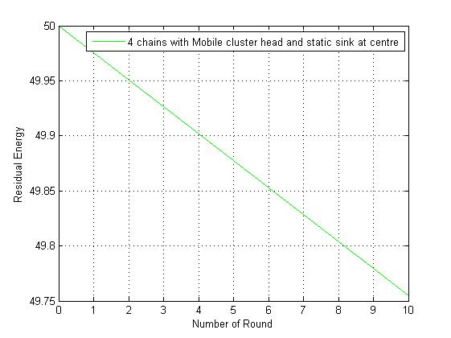

***AVERAGE ENERGY PER ROUND:***

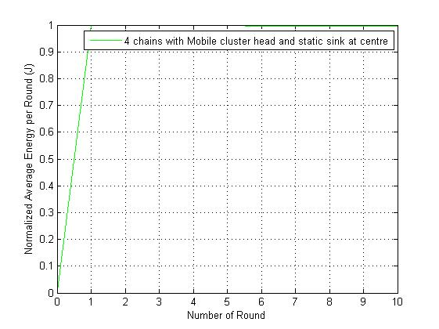

***NUMBER OF ALIVE NODES PER ROUND:***

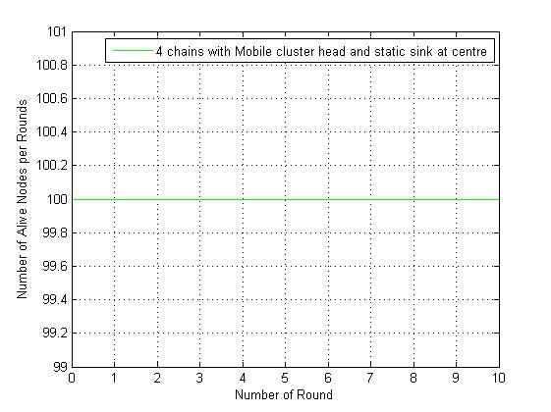

***NUMBER OF DEAD NODES PER ROUND:***

